**COAL LAB 09 (1) TASKS**

**Task#01(a):**

**CODE:**

TITLE Task1(A) (test.asm)

INCLUDE IRVINE32.INC

.data

var dword 5

x dword ?

message byte "The value of x : ",0

.code

main proc

mov ecx, 3

mov edx, 4

cmp var, ecx

jc l1

jmp l3

l1:

cmp ecx, edx

JGE l2

jmp l3

l2:

mov x, 0

jmp outside

l3:

mov x, 1

mov edx, offset message

call writeString

mov eax, x

call writeDec

call crlf

call crlf

outside:

call dumpregs

exit

main endp

end main

**OUTPUT:**

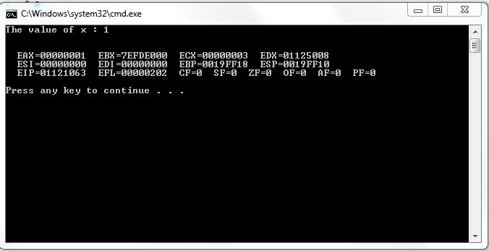

**Task#01(b):**

**CODE:**

TITLE Task1(B) (test.asm)

INCLUDE IRVINE32.INC

.data

var dword 0

maxcount dword 10

message1 byte "Hello",0

message2 byte "World",0

.code

main proc

mov ecx, 10

l1:

mov eax, maxcount

cmp var, eax

JG outside

mov eax, var

mov edx, 0

mov ebx, 2

div ebx

cmp edx, 0

jz l2

jmp l3

l2:

mov edx, offset message1

call writestring

call crlf

jmp l4

l3:

mov edx, offset message2

call writestring

call crlf

l4:

add var,1

loop l1

outside:

call dumpregs

exit

main endp

end main

**OUTPUT:**

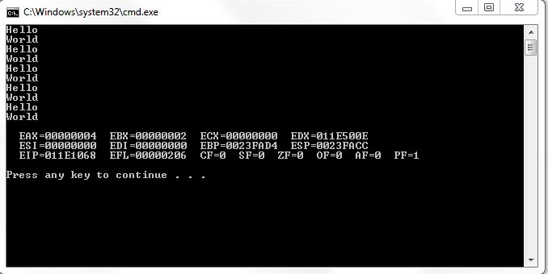

**Task#03:**

**CODE:**

TITLE Task3 (test.asm)

INCLUDE IRVINE32.INC

.data

intArr SWORD 0, 0, 0, 0, 1, 20, 35, -12, 66, 4, 0

message byte "The first non zero number : ", 0

.code

main proc

mov esi, offset intArr

mov eax, 0

l1:

mov ax, [esi]

cmp ax, 0

jnz outside

add esi, 2

loop l1

outside:

mov ax, [esi]

mov edx, offset message

call writeString

call WriteDec

call crlf

call crlf

call dumpregs

exit

main endp

end main

**OUTPUT:**

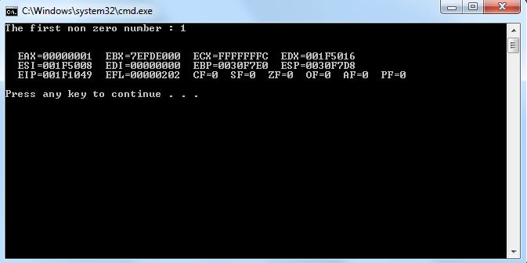

**Task#04:**

**CODE:**

TITLE Task4 (test.asm)

INCLUDE IRVINE32.INC

.data

var dword 4 dup(?)

message1 byte "Enter 4 integers : ",0

message2 byte "These 4 numbers are equal!",0

message3 byte "These 4 numbers are not equal!",0

.code

main proc

mov edx, offset message1

call writeString

mov ecx, 4

mov esi, offset var

l1:

call readDec

mov [esi], eax

add esi, 4

loop l1

mov esi, offset var

mov ecx, 3

l2:

mov eax, [esi]

cmp eax, [esi+4]

jnz outside

add esi, 4

loop l2

output:

mov edx, offset message2

call writeString

jmp next

outside :

mov edx, offset message3

call writeString

next:

call crlf

call crlf

call dumpregs

exit

main endp

end main

**OUTPUT:**

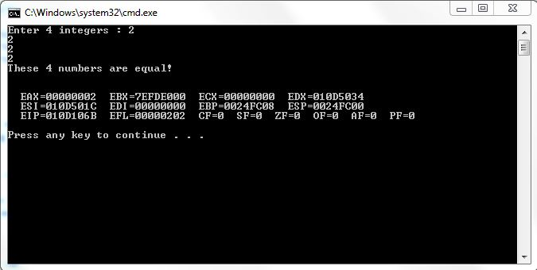

**Task#06:**

**CODE:**

TITLE Task6 (test.asm)

INCLUDE IRVINE32.INC

.data

arr WORD 10, 4, 7, 14, 299, 156, 3, 19, 29, 300, 20

var word ?

message1 byte "The number you entered, found in array!",0

message2 byte "The number you entered, not found in array!",0

prompt byte "Enter any number : ",0

.code

main proc

mov eax, 0

mov edx, offset prompt

call writeString

call readDec

mov var, ax

mov esi, offset arr

mov ecx, lengthof arr

mov eax, 0

mov ax, var

l1:

cmp ax, [esi]

jz outside

add esi, 2

loop l1

next:

mov edx, offset message2

call WriteString

jmp outtt

outside:

mov edx, offset message1

call writeString

outtt:

call crlf

call crlf

call dumpregs

exit

main endp

end main

**OUTPUT:**

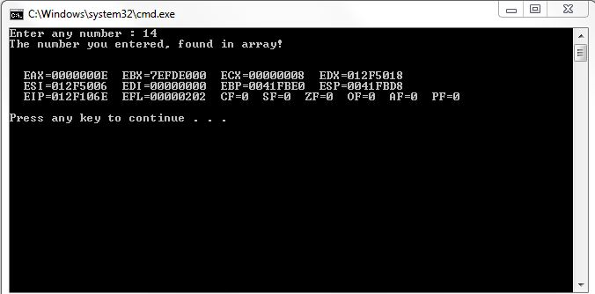

**Task#07:**

**CODE:**

TITLE Task7 (test.asm)

INCLUDE IRVINE32.INC

.data

arr WORD 10, 4, 7, 14, 299, 156, 3, 19, 29, 300, 20

Swap_Count byte 0

prompt byte "Number of swaps performed : ",0

.code

main proc

mov ecx, lengthof arr-1

mov esi, offset arr

mov eax, 0

l1:

mov ax, [esi]

cmp ax, [esi+2]

jg l2

jmp next

l2:

mov bx, [esi+2]

mov [esi], bx

mov [esi+2], ax

inc Swap_Count

next:

add esi, 2

loop l1

mov edx, offset prompt

call writeString

mov eax, 0

mov al, Swap_Count

call WriteDec

call crlf

call crlf

call dumpregs

exit

main endp

end main

**OUTPUT:**

